# The Vedic APIs

# Introduction

All of the data in the Vedas, presented as JSON dictionaries through APIs.

These APIs make available to you two kinds of data:

* The gods and poets, their categories, and poem meters used in all of the Rig Veda verses.
* The descriptions of all the nouns (except proper nouns) mentioned in vedic literature is explained in the following vs API reference section.

# vs API reference

**Introduction**

The Rig Veda vs API reference is a description of all of the nouns in vedic literature, including the flora, fauna, geography, food, relationships, and objects.

vs = Vedic Society

**Method**

GET

**Base URL**

<https://aninditabasu.github.io/indica/html/vs.html#base>

**Endpoint:**

<https://api-vs.herokuapp.com/vs/v1/>

**Headers**

Authentication/Authorization**:** Not Auth

Content type: application/json

Response type: application/json

**Query Parameters**

**Note: A**ll of the parameters of the vs API are strings

| **Parameters** | **Optional/Required** | **Data type** | **Description** |
| --- | --- | --- | --- |
| word* | Required | String | The word is a noun in Sanskrit, used to interpret into the roman script, for the verse  For example: aksh. |
| nagari | Required | String | This is a noun, in the Nagari script. For example: अक्ष |
| description | Required | String | The description of the noun. |
| category | Optional | String | The category the noun belongs to. |

**Example response**

|  |
| --- |
| [  {  "word": "aksh",  "nagari": "अक्ष",  "description": "the axle of a chariot",  "category": "chariot"  },  {  "word": "aksh",  "nagari": "अक्ष",  "description": "dice",  "category": "dicing"  }  ] |

**Response Status code :** 200 OK

**Screenshot of the Postman UI**

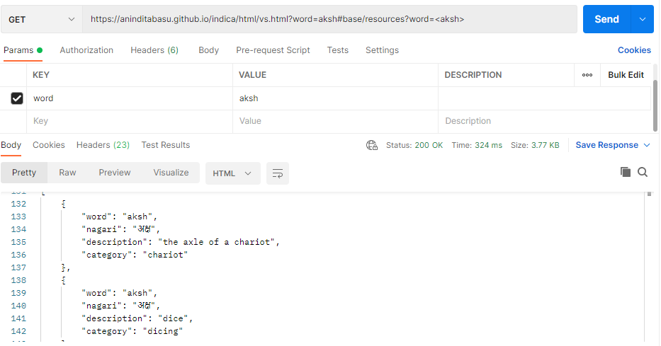

**Screenshot of the Postman UI**

